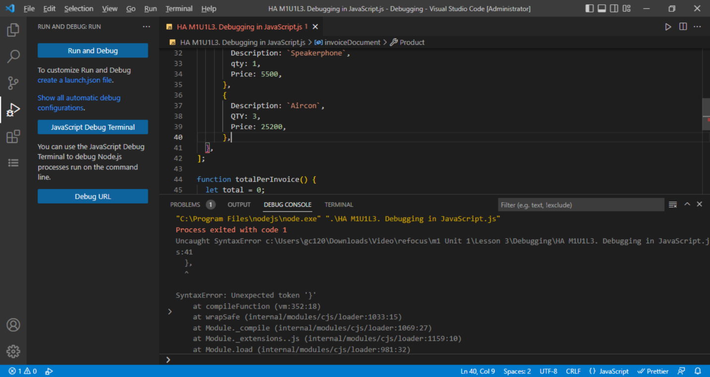

*Missing closing bracket in line 40*

Case 1. Missing closing bracket “***]***” at line 40. Solution: Added a closing bracket “***]***” at line 40.

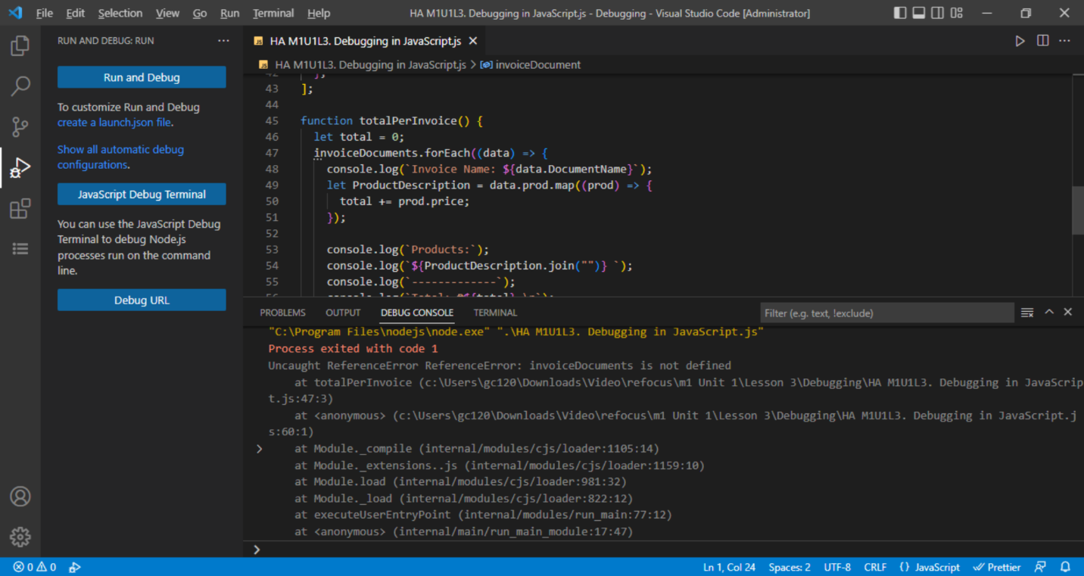

*invoiceDocuments is not declared, Instead invoiceDocument was declared starting at line 1*

Case 2. The variable ***invoiceDocuments*** found in line 47 is not declared. Solution: Change the variable name to ***invoiceDocument***.

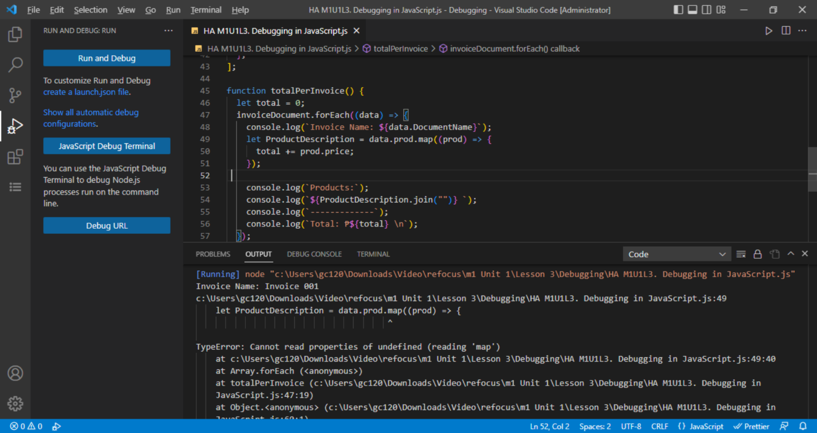

*prod property is not part of data*

Case 3. The property ***prod*** is not part of data. Solution: Change the variable name to ***Product***.

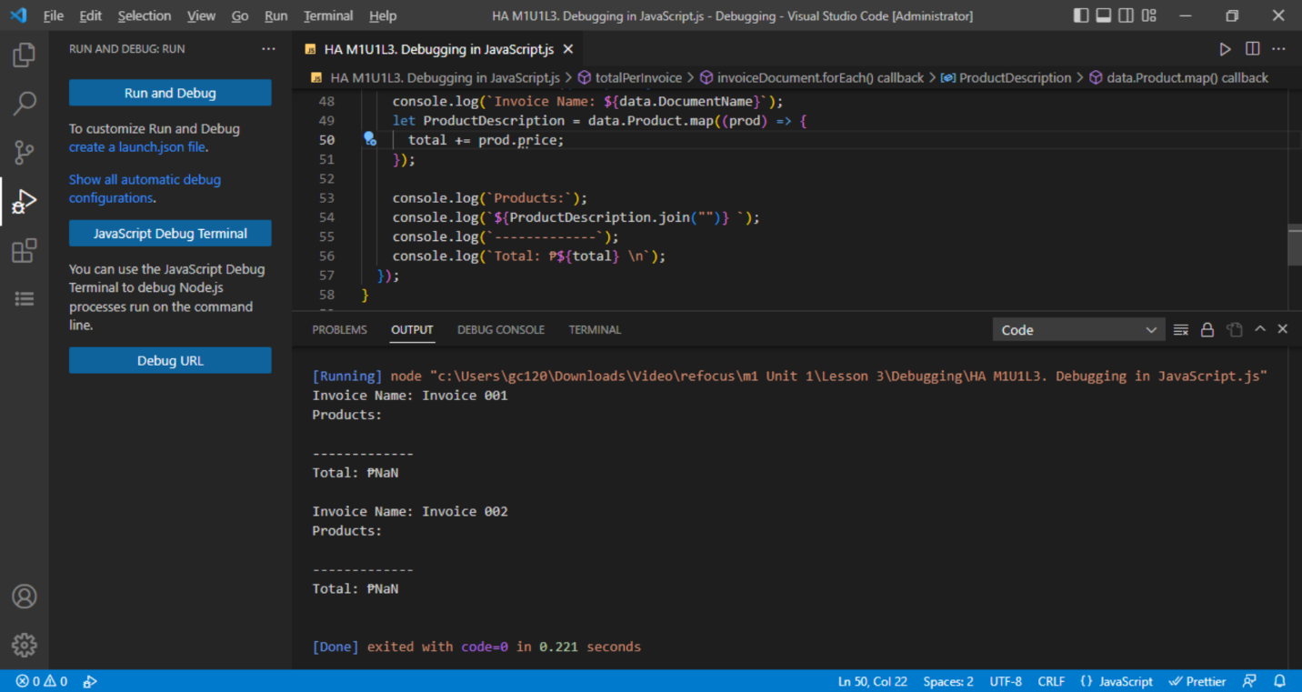

*prod property is not part of data*

Case 4. The property ***price*** does not exist in the context of ***Product***. Solution: Change variable name to ***Price***.

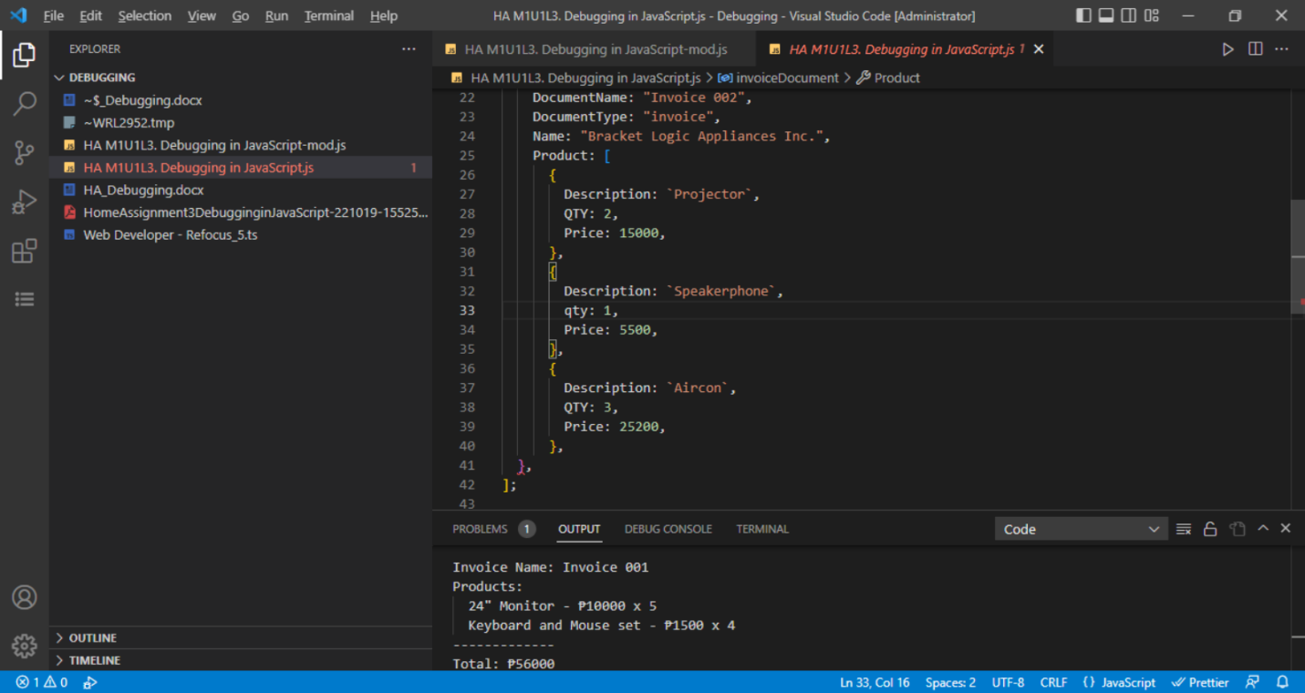

*qty property is different from the rest of product, all others are using QTY*

Case 5. The property ***qty*** differs from all of other items in Product. Solution: Change variable name to ***QTY***.

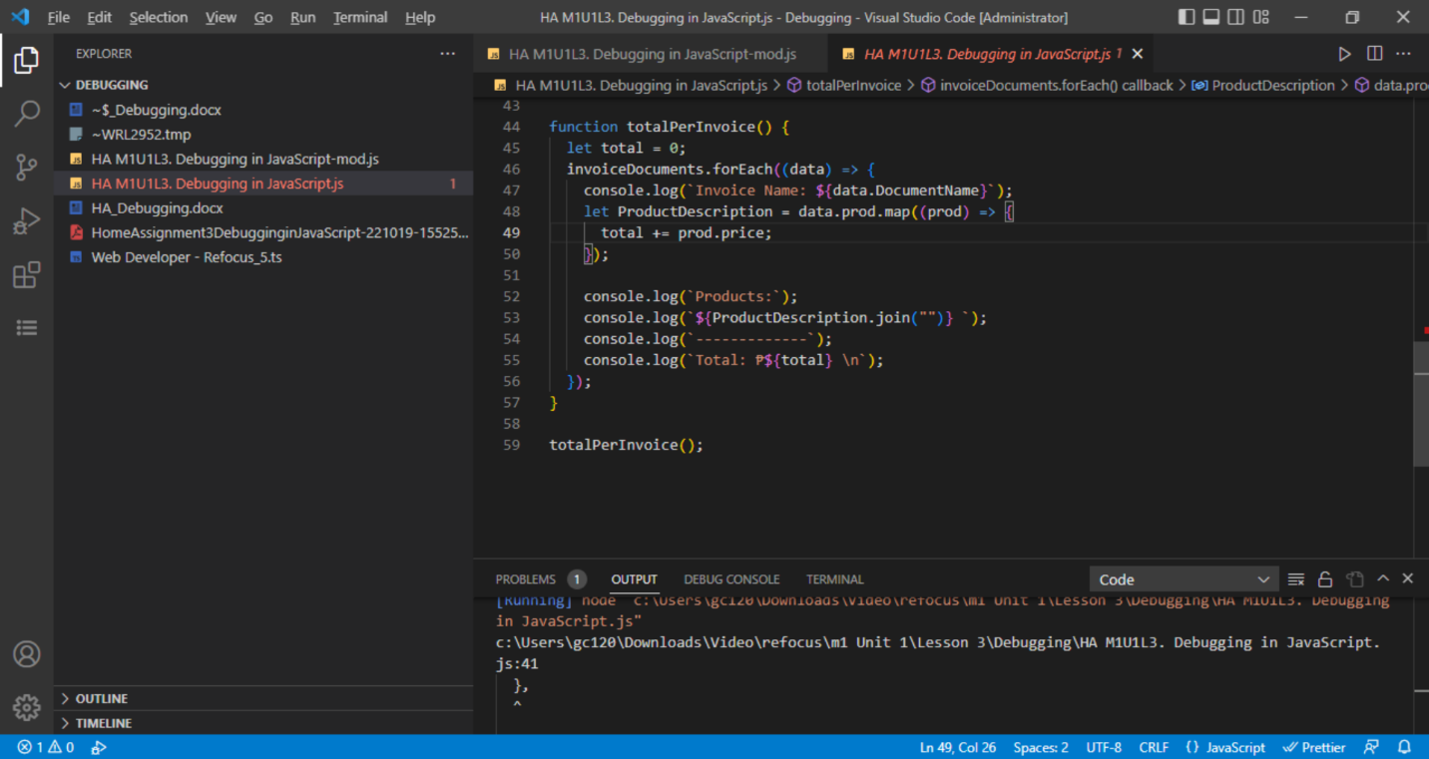

*Missing QTY in calculating total*

Case 6. The property ***prod.QTY*** is missing in the calculation of total . Solution: added * ***prod.QTY*** in the equation of total.



*Command could not list product of each invoice.*

Case 7. The command at line 53 was intended to list all product name, price and quantity, but obviously it can do as per intent . Solution: line 53 code was all deleted and replaced the ff. code

    data.Product.forEach((prod) => {

      console.log(`  ${prod.Description} - ₱${prod.Price} x ${prod.QTY}`);

    });

***Final Output:***

Invoice Name: Invoice 001

Products:

  24" Monitor - ₱10000 x 5

  Keyboard and Mouse set - ₱1500 x 4

-------------

Total: ₱56000

Invoice Name: Invoice 002

Products:

  Projector - ₱15000 x 2

  Speakerphone - ₱5500 x 1

  Aircon - ₱25200 x 3

-------------

Total: ₱111100

Note: the total of Invoice 002 as per questionnaire is Php 167100. I think it is a clearical error.